What does this have to do with Tobacco?

Pasco County SWAT provided awareness to many youth in Pasco County Wednesday at the YMCA after school program in celebration of “Kick Butts Day.” Amongst a table full of ice cream and various toppings, one would ask, “What does this have to do with tobacco?!”
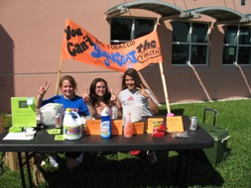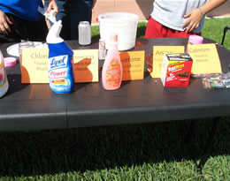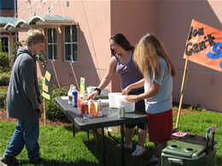

Well, Big Tobacco uses candy flavors such as ‘Camel’s Twista Lime to attract youth to smoke; therefore, Pasco SWAT used ice cream to distribute to the youth and added “poisons” on top. Chocolate chips represented arsenic, M&M’s represented ammonia, and various colored sprinkles represented acetone, chlorine, and cadmium. The YMCA youth were informed with each scoop of ice cream that Big Tobacco is adding all these types of chemicals to cigarettes and trying to cover up the deadly chemicals with candy flavors. This was to raise awareness about these and other hazardous chemicals in cigarettes despite the colorful, fun packaging and “sugarcoated” brands.

